MERN stack social media app notes

- Install express => express is the most common used tool to create server. It provides all the nessessary tools to build servers.
- Install mongoose => mongoose is a library used to create schemas of mongo-db inside our server
- install body parser=>It is used to check http request comes from our client side . It protects our server from crashing.
- Install nodemon => simple node will never save the fire save automatically. Nodemon will do this for us.
- In package.json add script “start”: “nodemon index.js”, whenever we start nodemon with this start command.
- Add type:”module”
- create file index.js

Index.js file
app.use(bodyParser.json({ limit: "30mb", extended: true }));

The limit option passed to bodyParser.json() sets the maximum size (in bytes) of the request body. In this case, the limit is set to 30mb, which means that any requests with a body larger than 30 megabytes will be rejected with a 413 (Payload Too Large) status code.
The extended option passed to bodyParser.json() is a flag that determines whether the parser should use the querystring library to parse the URL-encoded data in the request body. If extended is true, the parser will use the qs library to parse the data. If extended is false, the parser will use the built-in querystring library.
After setting up server we installed dotenv package
we know our connection string and port number to mongodb is confidential so we need to secure it. Dot env package helps us to store these enviornment variables inside .env file, which is secure.
- Import dotenv
- add dotenv.config()
- insted of using actual string we can use process.env.variable name.

Server Configuration
Our app starts from the index then it goes to Routes. Routes are pathways to different functionalities for example: User, Post, Auth etc. From routes to controllers. Controllers are nothing but just javascript functions. For example if we want to access authentication route from auth route it goes to auth controllers.
Models are the javascript scemas that our controllers will use to perform functionalities.

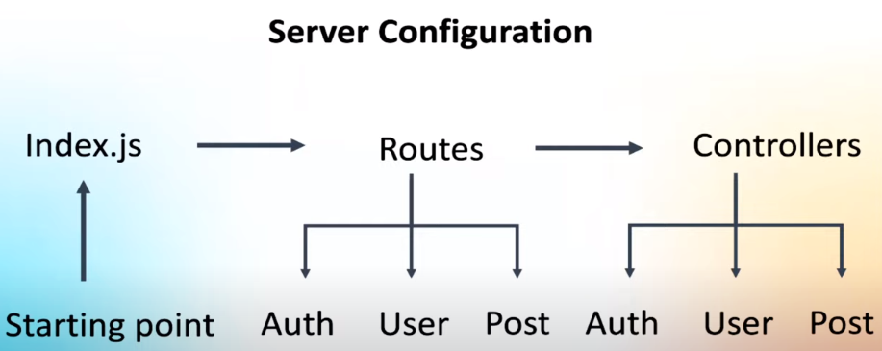
Inside Router folder we created a AuthRoute.js. Inside that we add Router() function. Identifies that it is a router.
const router = express.Router();
import the exported authroute and use it in index.js.
app.use('/auth', AuthRoute)
In order to access the authroute we need to go /auth first.
Route to register a new user on our application

First make a model for the user, ie schema. Inside model create file userModel.js
{timestamps: true} will create createdAt and UpdatedAt in out database automatically.

Create controller for Auth

Our complete logic comes inisde the controllers. Import usermodel and make an instance and fetach values ftom req.body and pass it to the database.

In here we are intracting with our server. There is a chance that we encounter an error. So we use try and catch block. Which is used to manage errors effeciently.

After wriitng the logic connect the controller with the route.
Writing password in its original format in data base is dangerous. We need to manipulate it programatically.
In this case we use library like bcrypt. It will encrypt the password programaticall with round functions.
const salt = await bcrypt.genSalt(10);
The salt value determine the amount of encryption it need. In our case i gave 10.
const hasedPassword = await bcrypt.hash(password, salt);
we will get a hashed password. We will pass this hashed password to the datbase.

Login Functionality

we need to check the password we receive from user and in database. In database our password is hashed so we use the same bcrypt library to compare passwords.
if(user){
const validity = await bcrypt.compare(password, user.password);
}

try {
const user = await UserModel.findById(id);
if (user) {
res.status(200).json(user);
}
} catch (error) {
res.status(500).json({ message: error });
}

This will get all the information from the user. To avoid this in our UserController
const { password, ...otherDetails } = user._doc;

res.status(200).json(otherDetails);

In the above code we are destructuring the password out and spread all the other details and send other details. This will help us to take out password.

const user = await UserModel.findByIdAndUpdate(id, req.body, {
new: true,
});

we update the user data with id and update from req.body. New: true means we always need to get the updated or latest data from the user.
If we want to update something we will use put.

